LLama 2

Pre-training
Stand transformer
pre-normalization using RMSNorm
SwiGLU as activtion
rotary positional embedding
context length 4K
grouped-query attention (GQA)
2.0T tokens

Hyperparameters.
AdamW optimizer with β1 = 0.9, β2 = 0.95, eps = 10−5 .
Cosine learning rate schedule: with warmup of 2000 steps, and decay final learning rate down to 10% of the peak learning rate.
Weight decay of 0.1 and gradient clipping of 1.0.

Evaluation data set

Code. We report the average pass@1 scores of our models on HumanEval (Chen et al., 2021) and MBPP (Austin et al., 2021). Commonsense Reasoning. We report the average of PIQA (Bisk et al., 2020), SIQA (Sap et al., 2019), HellaSwag (Zellers et al., 2019a), WinoGrande (Sakaguchi et al., 2021), ARC easy and challenge (Clark et al., 2018), OpenBookQA (Mihaylov et al., 2018), and CommonsenseQA (Talmor et al., 2018). We report 7-shot results for CommonSenseQA and 0-shot results for all other benchmarks.
World Knowledge. We evaluate the 5-shot performance on NaturalQuestions (Kwiatkowski et al., 2019) and TriviaQA (Joshi et al., 2017) and report the average.
Reading Comprehension. For reading comprehension, we report the 0-shot average on SQuAD (Rajpurkar et al., 2018), QuAC (Choi et al., 2018), and BoolQ (Clark et al., 2019).
MATH. We report the average of the GSM8K (8 shot) (Cobbe et al., 2021) and MATH (4 shot) (Hendrycks et al., 2021) benchmarks at top 1.
Popular Aggregated Benchmarks. We report the overall results for MMLU (5 shot) (Hendrycks et al., 2020), Big Bench Hard (BBH) (3 shot) (Suzgun et al., 2022), and AGI Eval (3–5 shot) (Zhong et al., 2023). For AGI Eval, we only evaluate on the English tasks and report the average.

Fine-tuning
Quality Is All You Need. Third-party SFT data is available from many different sources, but we found that many of these have insufficient diversity and quality — in particular for aligning LLMs towards dialogue-style instructions.
We stopped annotating SFT after collecting a total of 27,540 annotations.
Fine-Tuning Details. For supervised fine-tuning, we use a cosine learning rate schedule with an initial learning rate of 2 × 10−5 , a weight decay of 0.1, a batch size of 64, and a sequence length of 4096 tokens.

RLHF

Human Preference Data Collection
Annotators wrote a prompt, sampled from two different model variants
Focus on Helpful and Safety

Reward Modeling

Meta reward modeling data
Open source + 1 million binary comparisons
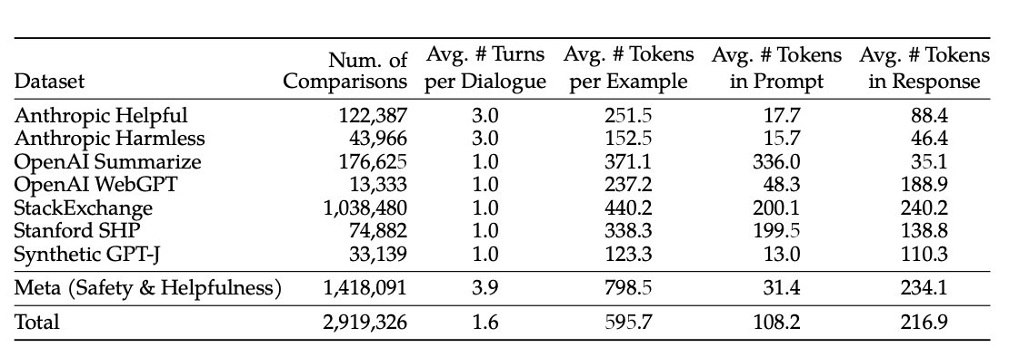
Lranking = −log(σ(rθ(x, yc) − rθ(x, yr) − m(r))) (2) where the margin m(r) is a discrete function of the preference rating.

Two models: helpfulness RM and Safety RM

Scaling Trends:
More data and large model

Iterative Fine-Tuning
PPO
Rejection Sampling fine-tuning. We sample K outputs from the model and select the best candidate with our reward, consistent with Bai et al. (2022b). The same re-ranking strategy for LLMs was also proposed in Deng et al. (2019), where the reward is seen as an energy function. Here, we go one step further, and use the selected outputs for a gradient update. For each prompt, the sample obtaining the highest reward score is considered the new gold standard. Similar to Scialom et al. (2020a), we then fine-tune our model on the new set of ranked samples, reinforcing the reward.

